Student F1 VISA Prediction Based on Student’s Profile

**NAME OF THE PARTICIPANTS**

|  |  |
| --- | --- |
| Suhas Siddarajgari Tellatakula | 11626111 |
| Sai Tejesh Gonemadatala | 11608671 |
| Sai Praneeth Reddy Avula | 11582402 |
| Sai Rohith Varma Kantem | 11606743 |

**UNDER THE GUIDANCE**

**Dr. Zeenat Tariq**

PROF. OF THE DEPARTMENT OF COMPUTER SCIENCE AND ENGINEERING

University Of North Texas, Denton

**INDEX**

|  |  |
| --- | --- |
| TOPICS | PAGE NO |
| INTRODUCTION | 3 |
| MOTIVATION | 3 |
| SIGNIFICANCE | 3 |
| OBJECTIVE | 3 |
| RELATED WORK | 4 |
| DATASET | 5 |
| ARCHITECTURE DIAGRAM | 6 |
| DETAILED FEATURES | 7 |
| WORKFLOW | 8 |
| IMPLEMENTATION | 9 |
| DATA PRE-PROCESSING | 27 |
| ANALYSIS AND PRELIMINARY RESULTS | 37 |
| MACHINE LEARNING | 39 |
| RESULTS | 45 |
| FINAL COMPARISON & PREDICTION CHECK | 65 |
| PROJECT MANAGEMENT | 67 |
| REFERENCES / BIBLIOGRAPHY | 69 |

**Introduction / Abstract**

Every year thousands of students appear for visa interviews to study in universities abroad. And only a handful of them clears the visa interview. The student would never know the reason for rejection. Often the visa officer evaluates the student’s profile and issues a visa. If there are any drawbacks in the student profile then there is a high chance that the student might face rejection. The application we developed will evaluate students’ profiles based on the criteria like student scores, work experience, Family background, etc., and outputs the chance of getting a visa approved in percentage. The application also suggests where the student is lacking. Thus, helping in building the student profile to increase the chance of getting approved.

**Motivation :**

There is a tremendous increase in the number of students planning to pursue higher studies in a foreign country. But among thousands of applications, only a few students clear the visa process and get their visas approved by their desired country’s embassy. This usually happens because of a lack of knowledge of the criteria that the embassy used to evaluate the applicant’s profile. To tackle this problem we are attempting to build an effective solution that accepts student profiles as inputs like their family background, academic test score, and other appropriate information and predicts the visa chances of the applicant.

**Significance of the tool:**

There is no tool or solution available online where a person can check his / her F1 visa approval chances. Therefore , this tool will be highly helpful for such candidates as he / she can easily check the chances of visa approval. Based on the results given by this tool , candidate can prepare or update his/her profile so that one can increase the chances. In this way , the tool can help save candidates time and money by booking the slot after improving the profile.

**Objectives:**

This tool is aimed to do the following things:

* To output a percentage value indicating the candidates’ Visa chances.
* Tool must be able to eliminate null entered rows from the data set and exclude them from getting trained for the machine learning model.
* To run different machine algorithms and choose the best model.
* To analyze the Visa_Candidates data and use Hadoop components to produce statistics for the data.

**Features of the tool:**

* The main feature of this solution is to give the visa prediction chances for a candidate based on the

machine learning model built on his/her features.

* One of the features is to analyze the given Visa_candidates csv data using the different components like Hadoop HDFS , Hive , Hue , Solr , Lucene, Cassandra.
* To build 5 regression models on the split data and analyze the accuracy of predictions of these models.
* Another feature is that the tool should remove any null entered rows and duplicate rows.

**Related Work (Background):**

Many students approach consultancies for profile evaluation and spend a lot of money to identify drawbacks in their profiles. So, to address this problem we started researching about different possible ways to find a solution. Using Artificial Intelligence models and relevant datasets we can predict the chance of getting approved. But there isn’t any suitable dataset that is readily available online. So we started looking for the dataset that is closest to our desired dataset and we found a dataset on Kaggle that matches our requirement. The name of the data set is “Graduate Admission Prediction”. We took this dataset deleted irrelevant columns and added more columns that are required.

For the Machine Learning and Data science part , there were very few insights from the internet. Since there are not any projects directly related to our problem statement but few similar ones like “predicting the H1B Visa Status” was found . But this project is again a classification project while what we are trying to predict is regression problem . Therefore , we used this as a reference while doing this project.

**References:**

1. <https://www.kaggle.com/code/aryantiwari123/graduate-admission-prediction>
2. <https://www.kaggle.com/datasets/saddamazyazy/go-to-college-dataset>
3. <https://www.kaggle.com/code/akhilkasare/h-1b-visa-prediction-using-machine-learning>
4. <https://www.kaggle.com/code/campusx/gre-admission-prediction/data>

**Dataset:**

The dataset that we are working on has 17 columns of which 16 columns are regular columns that are used for prediction and one main column called Chance of visa approval is used to display the result. The dataset includes important columns like Gre and tofel scores, university ratings, CGPA, work experience, US relatives, no of times rejected earlier, and no of backlogs.

Our dataset has 400 records of which 300 records are used for training purposes and the rest 100 are used for testing purposes.

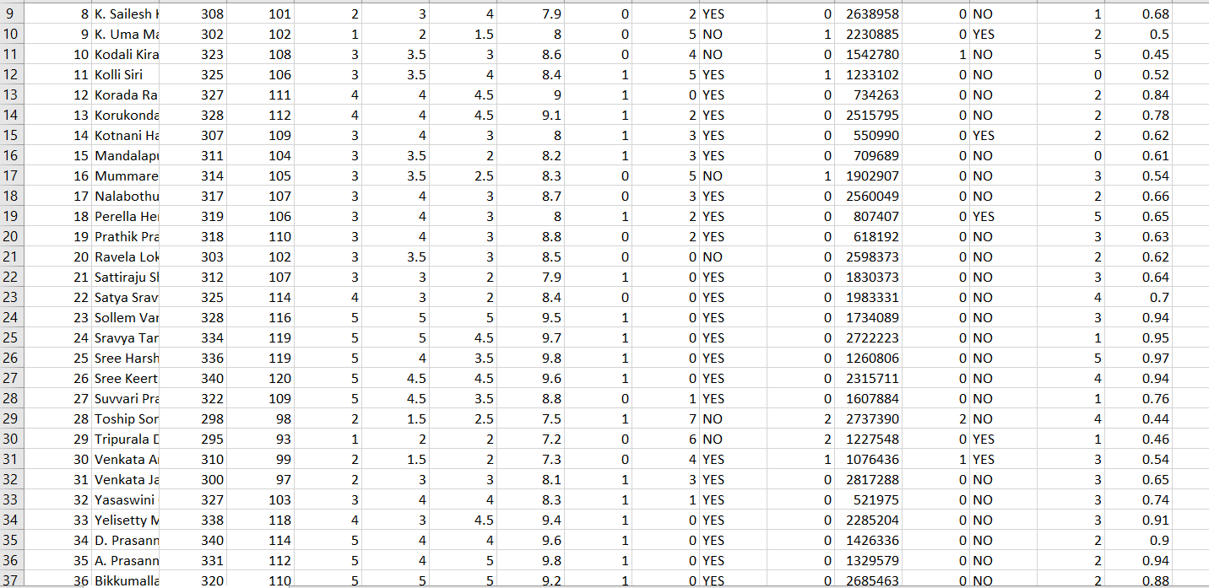

**Features And Implementation:**

**Architecture/Model:**

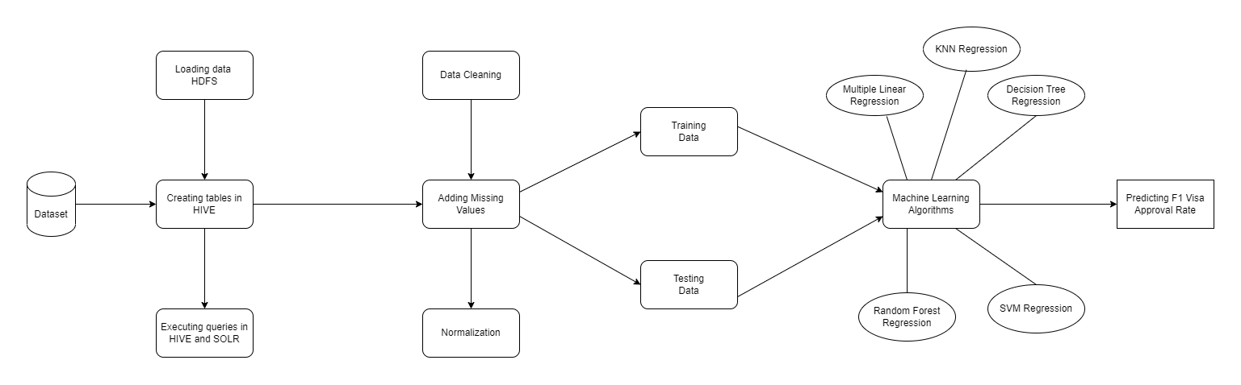

Fig 1. Architecture Model

**Evaluation models:**

Firstly, we load the dataset into Hadoop Distributed File System (HDFS). From the data, we create tables in the hive by mentioning appropriate data types and Primary keys. Once the table is created, we can use queries to manipulate the data in these tables and can display results. For executing queries, we have used a Hadoop component called HIVE and SOLR which is a java-based search platform. With this, the data analysis part is completed and later we clean the data and pre-process the data to train ML models.

1. The first step is to fetch an appropriate dataset with a decent number of records that matches the requirement.
2. After fetching the dataset, the next step is to analyze the dataset. In this project, we have used Hadoop ecosystem components for data analysis. In data analysis, we load data into HDFS, create tables in the hive, and use HIVE and SOLR for executing queries
3. Next step after data analysis is data preprocessing. In this step, we clean the data I.e., we eliminate null values and remove any unwanted data. We add any missing value to the columns in the tables.
4. After the above step the dataset is ready, now using the dataset we train ML models by using 75% of available data, and the remaining 25% is used for testing purposes.
5. Furthermore, once the ML models are trained, we use different Machine learning algorithms like K- Nearest neighbor and Random Forest and select the best algorithm which gives the highest accuracy.
6. The last step is to display the chance of F1 visa approval to the student based on the student’s profile and we’ll suggest in which areas the student can improve his profile to increase the chances of getting approved.

**Detail design of Features:**

* As mentioned earlier, to predict the F1 visa approval rate we take the student’s profile like student CGPA, GRE and TOFEL scores, work experience, no of backlogs, and no of times previously refused as inputs. We are using HiveQL language to write queries and manipulate data in datasets.
* To visualize the results after analyzing the data we are using excel to generate meaningful pie charts and bar graphs. In later increments, we will use data visualization python libraries like matplotlib to represent results.
* Using our custom dataset, we are training and testing Machine Learning models. These ML models analyze student’s profiles and identify the areas where a student is lacking. For instance, If the student has low GRE scores the application suggests reappearing for exams to get better scores.

**Workflow:**

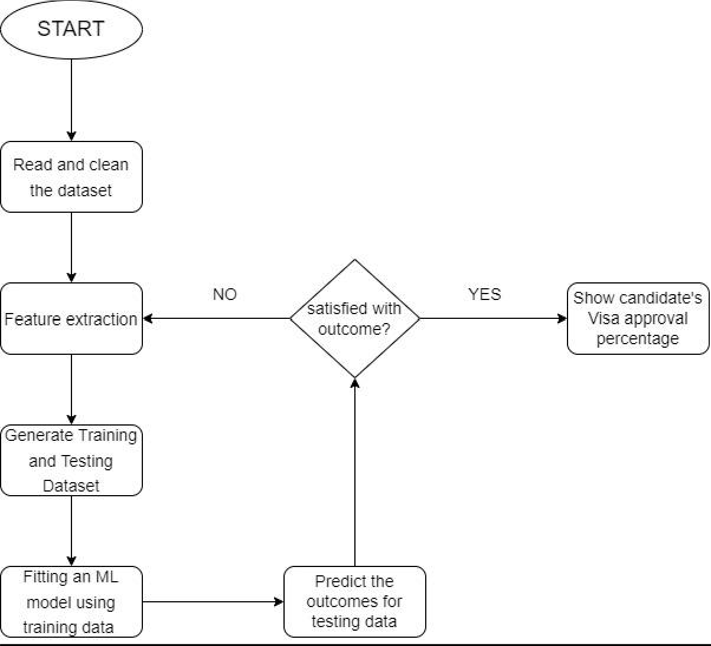

Fig 2. Work Flow Diagram

**Workflow description:**

We start by collecting data, and after collecting data we read that read and clean using python during the cleaning phase we look for null values and eliminate those values from the data set. Once the data is cleaned and ready, we move to the feature extraction stage. In this phase, we transform some raw data into numerical values. The data thus available is split into two parts, One part is used for training purposes and another part is used for testing the ML models. After that using machine learning algorithms, we predict the outcomes of testing data. If the results are satisfactory then we proceed to the next step which is displaying the chances of getting a visa approved. If the results are not up to the mark, then we move back to the feature extraction step and reiterate the whole process until a satisfactory outcome is produced.

**Implementation:**

We Installed Virtual Machine on our host system, opened Cloudera in Virtual System, and worked on the Cloudera platform. Open a terminal in Cloudera.

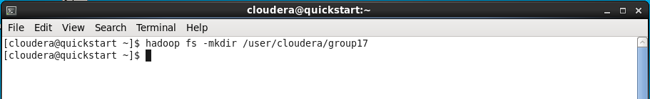

Now we have created a new directory named “group17” by using the “mkdir” function.

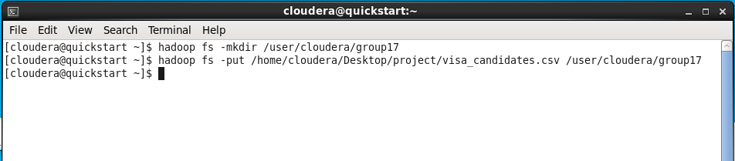

We have our source file “visa_candidates.csv” on the Desktop. Now we are moving our source file from the desktop to the directory “group17” which we have created before.

Visualizing the data in “Hue” to check whether the Dataset loaded into HDFS successfully or not.

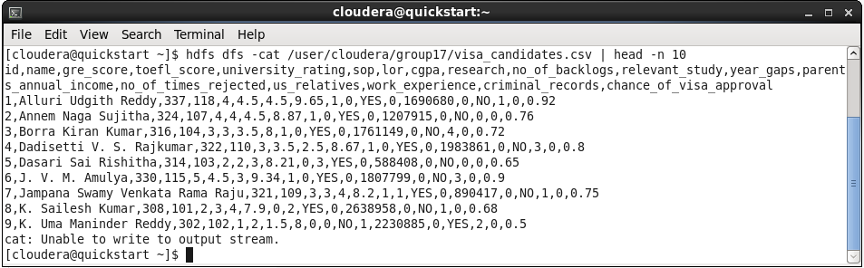

We have used the “cat” command and “head” command to display the first ten lines of the Data from our source file “visa_candidates.csv”

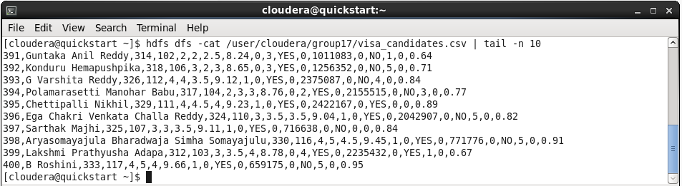

Now we are visualizing the last ten lines from our source file by using the above “cat” and “tail” commands.

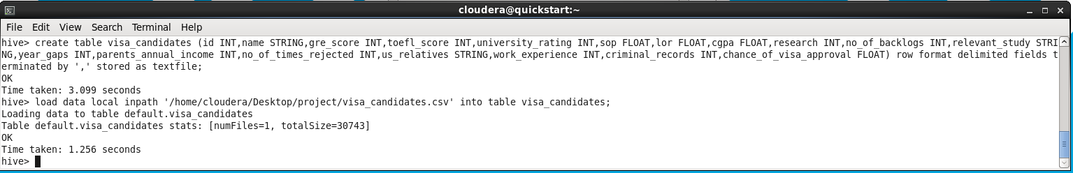

We Create the tables in HIVE and load the entire dataset.

To load the Data into the table which we have created. HIVE provides us with the facility to load datasets from files that hold on HDFS.

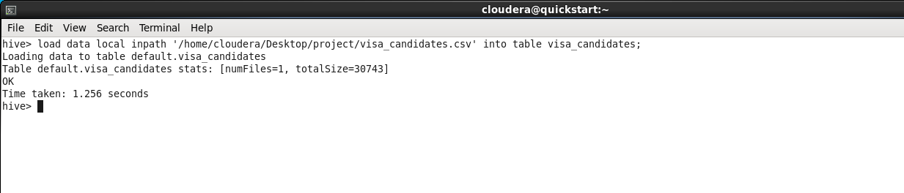

The Command used to load the data is:” LOAD DATALOCAL INPATH WRITE INTO TABLE”;

Display data in Command Prompt in HIVE

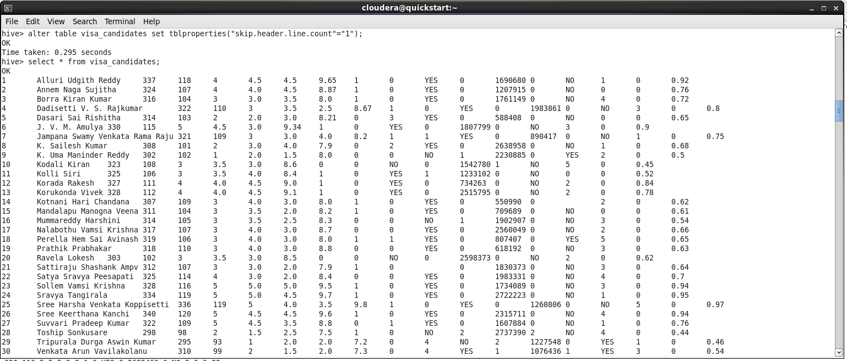

Using “select” command we displayed the data that is loaded into the table by this we can confirm that the data is successfully loaded into the table

Visualize un Hue

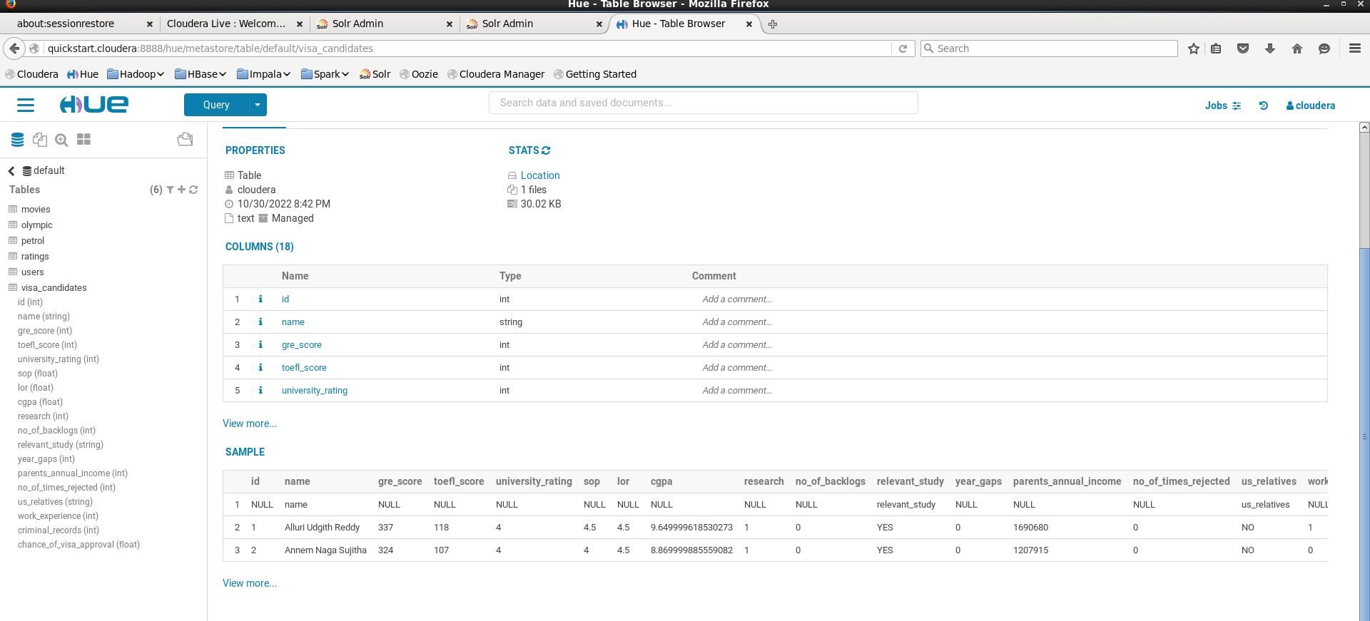

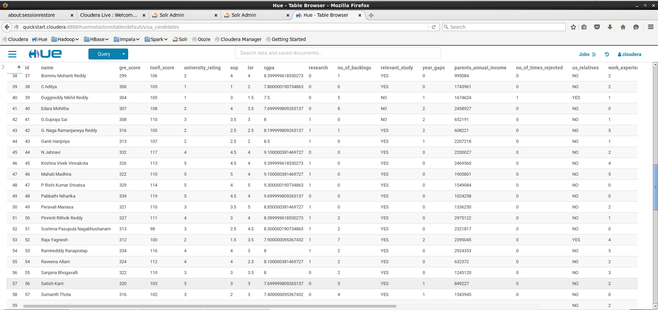

Displaying the loaded dataset in HUE browser by which we can check the data that is loaded into the table we created is

**Finding Names and scores whose gre>320 and toefl>115**

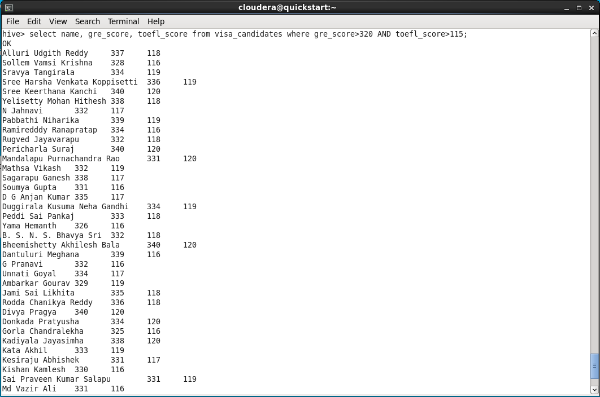

We are listing out the people who secured “gre” score above 320 and “toefl” score above 115 by using the above queries.

The main purpose of executing this query to list the people with high GRE and TOEFL scores so they have the most

visa acceptable.

**Finding names and cgpa for top universities**

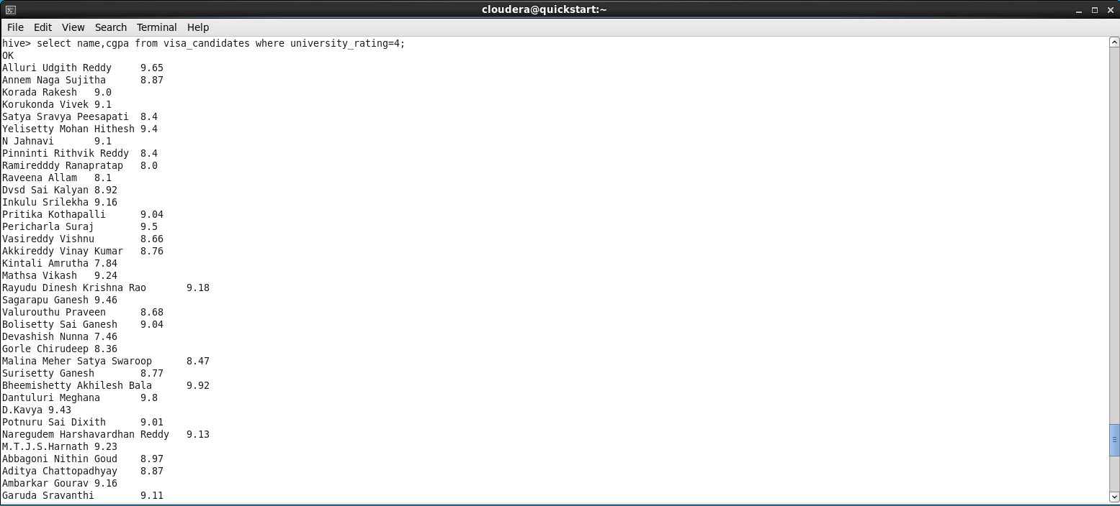

We are finding the people who are form top rated universities by using the above queries. In querie we analyze the dataset and provided the cgpa and name of students from top rated

universities.

CGPA of the students also comes into picture when considering for the visa approval so we have taken this query for checking the candidates.

**Avg of visa approval**

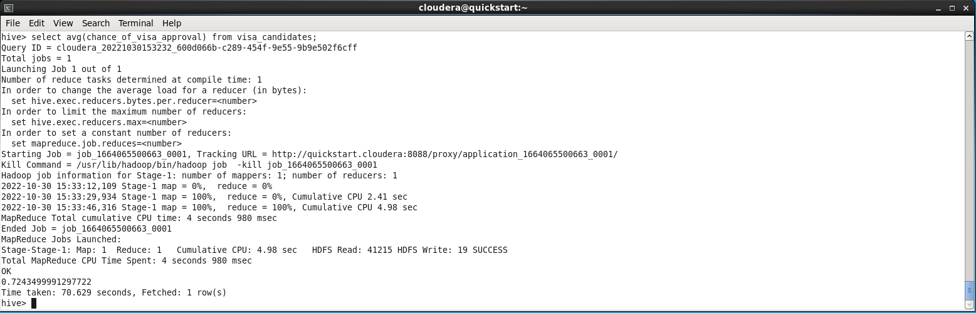

We are finding the average visa approval rate by using above querie. This quire calls the mapper, reducer because the task executed through MapReduce process.

**Finding people with more criminal records**

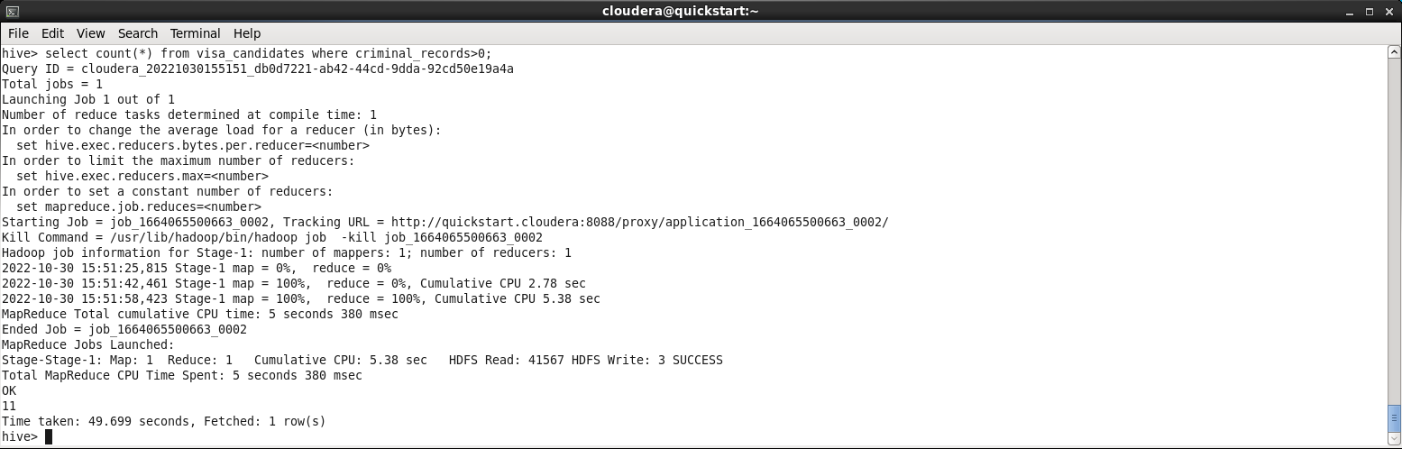

In order for easy verification and approval of visa for any person their criminal record is checked all the time. Now here we are finding the number of people who have criminal record on their profile. For this task the above querie calls the MapReduce process.

People with more criminal records have the least visa approval rate so, A condition is checked that people with more criminal records the least chance of visa approval.

**Avg of parent’s income**

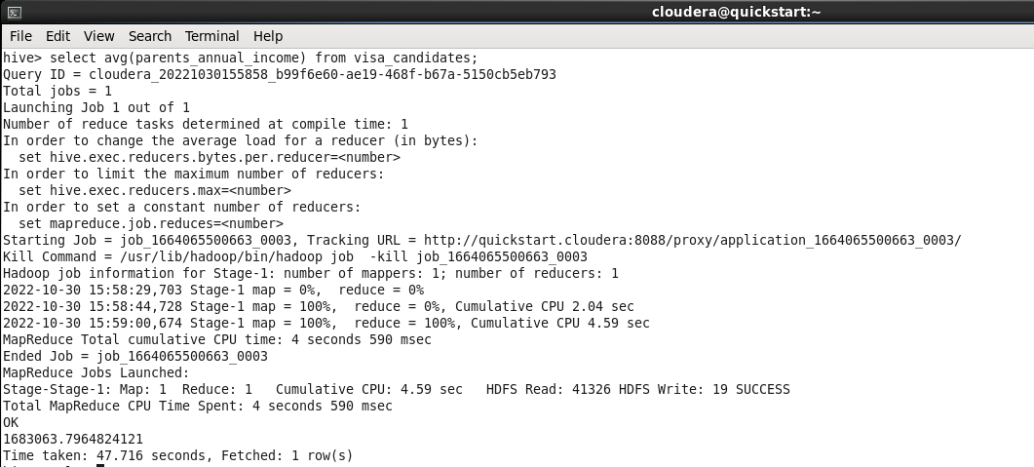

For some particular visa’s like f1and j1, we need check the income in their bank account on in their parent’s bank account as most common of all these are “F1” visas which student visa so some has to sponsor them for their education. So, we are Finding the average income of parents of people who applied for visa. the above querie uses the MapReduce process to analyze the large data and provide accurate output.

**Finding the top ten people visa approval rate**

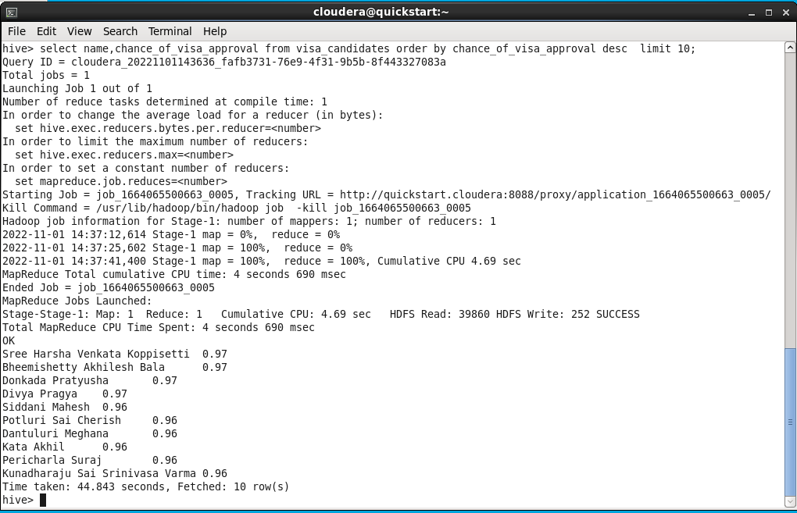

Based on the data we find the top people with visa approval rate for this task we used above queries which calls the MapReduce which retries the accurate data

To display the top 10 students with high visa approval rate so that they can get an idea about who are the highest visa approved students.

**Finding the last ten people visa approval rate**

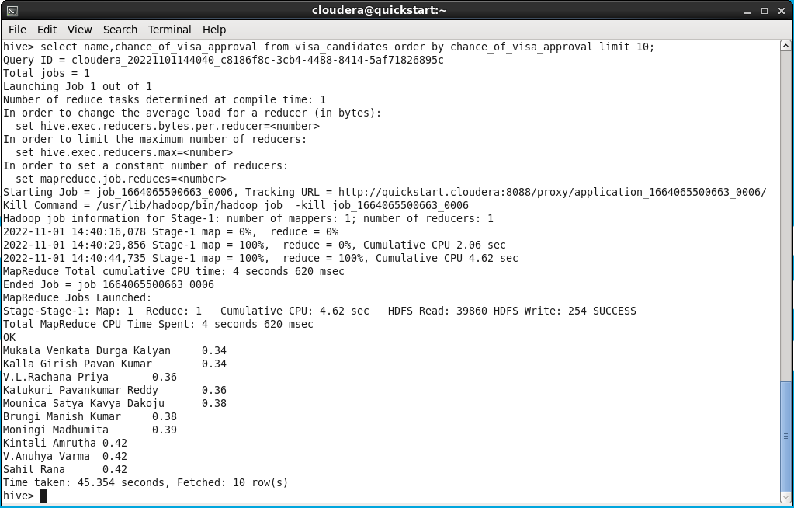

Based on the data we find the least people with visa approval rate for this task we used above queries which calls the MapReduce which retries the accurate data

To display the least 10 students with high visa approval rate so that they can get an idea about who are the least visa approved students.

Final query

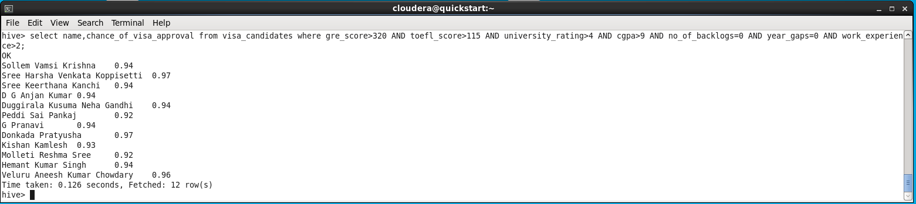

Here we are displaying the data of people whose profile is perfectly suited for visa approval based on their GRE, TOEFL scores along with the rating of their university and CGPS secured.

SOLR

Now we are performing several tasks on the visa_candidates dataset using the SOLR tool

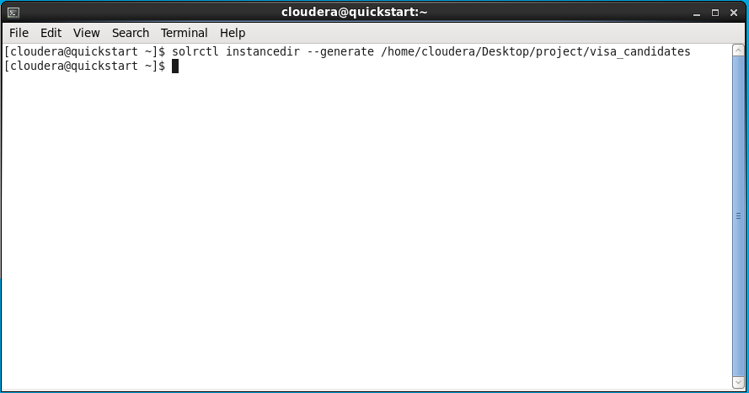

The above command is used for creating a new instance for the “visa_candidates” and you can see a folder is created on the name “visa_candidates” in which all the schema and other configurations are stored.

Changing Schema



We need to edit the schema because all are not present in the old schema to add new features we are changing the schema using gedit.

We will change the schema in the schema.xml

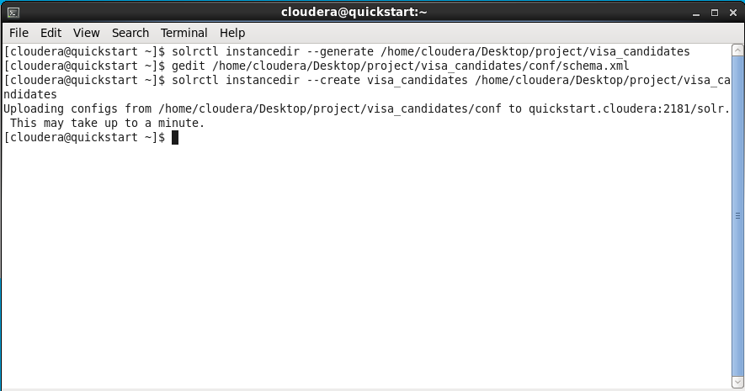

Here in the --create command the contents of the instance directory are uploaded to the zookeeper.

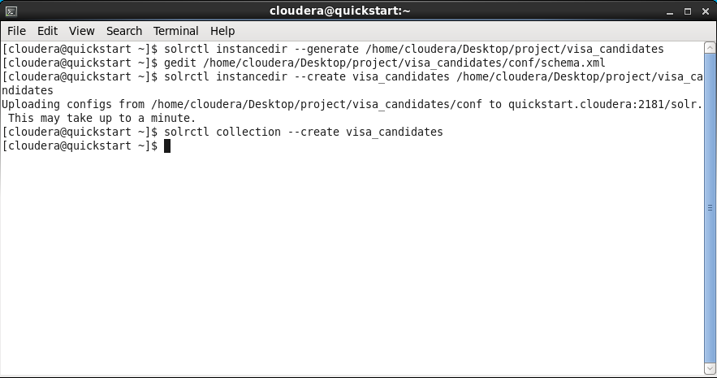

Here the “--create visa_candidates” command a new collection is created in the solr which is named visa_candidates

Loading Data into SOLR

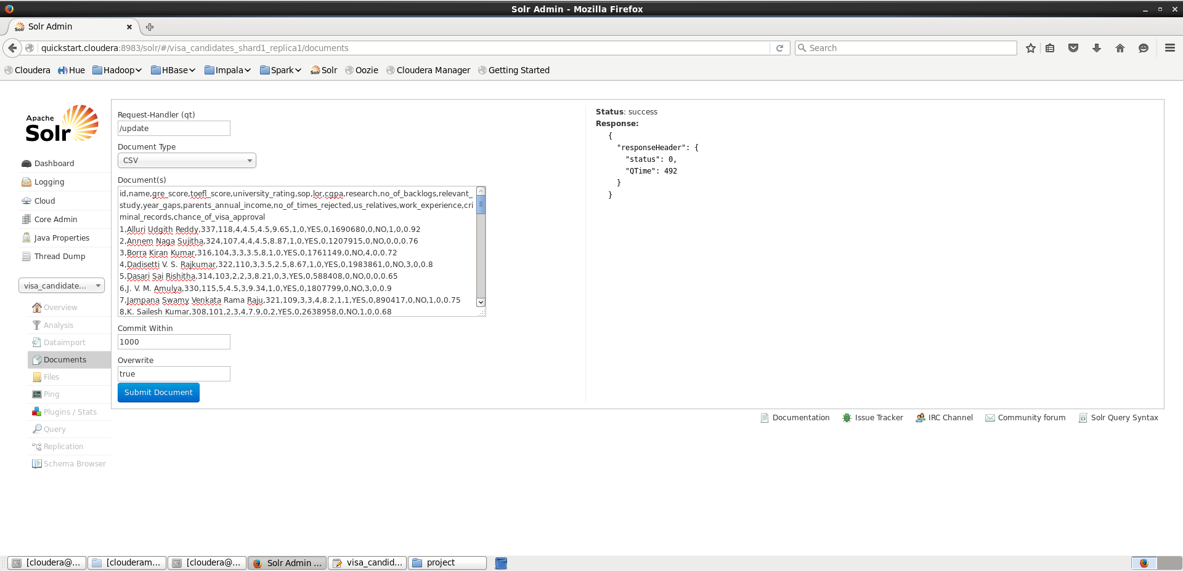

For uploading the data into solr we follow these steps, Open solr and go to Core-Admin there you can find the visa_candidates. Now select the visa_candidates from the selector and make sure the document type is ‘CSV’ then upload all the data from the visa_candidates dataset into the document section of solr and then click submit Document button for submitting.

Displaying the data

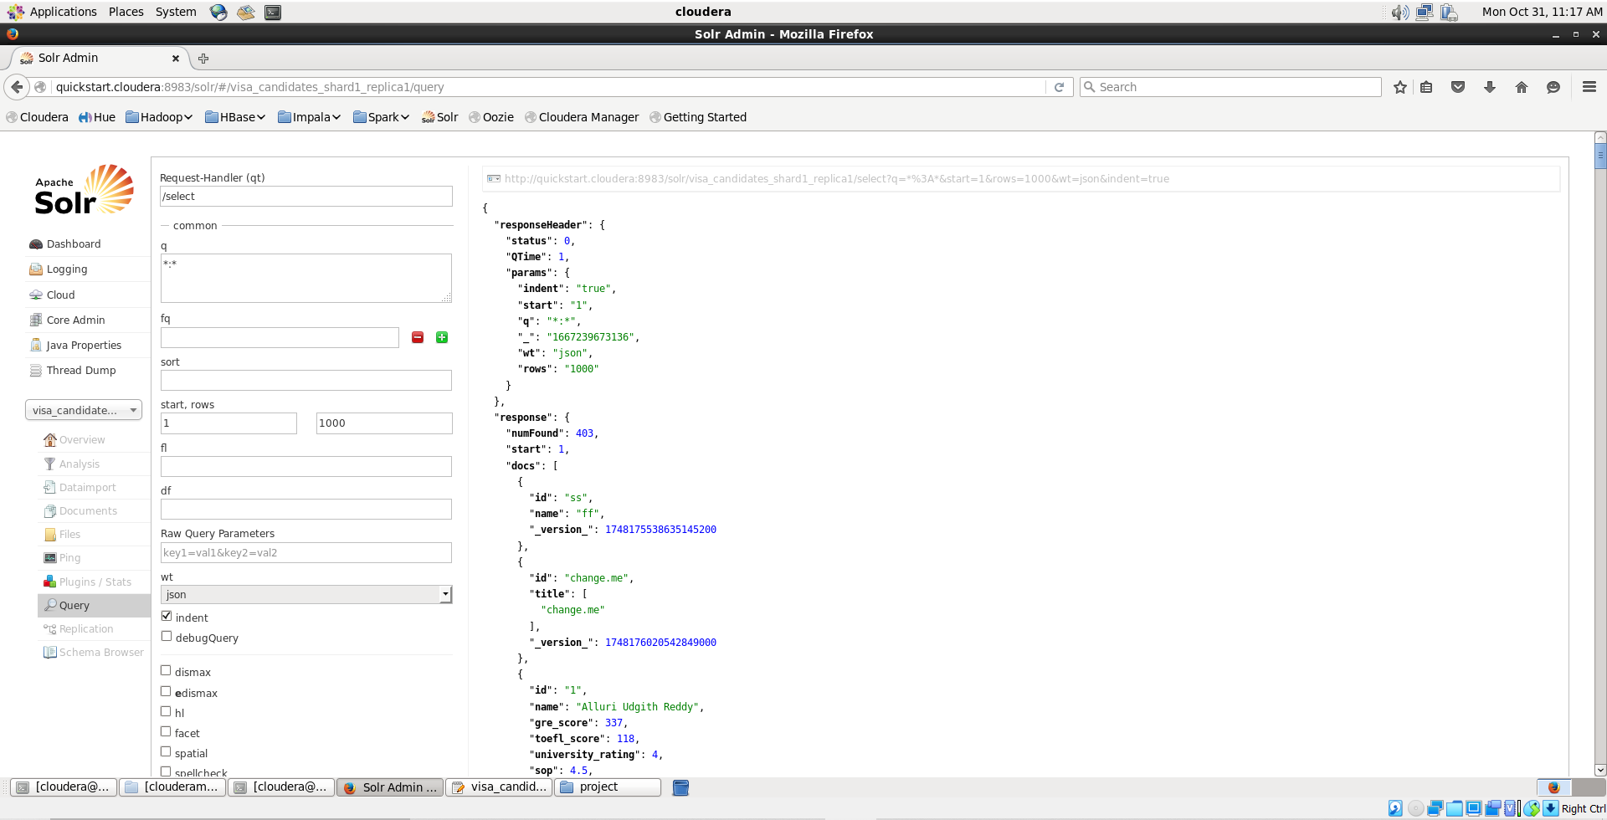

Here we are listing all the data of visa-applied candidates, we used the above queries “*;*” we should add the id, name, gre_score, .. etc. then the data will be retrieved.The abovee im is the output.

Finding ‘gre’ and ‘toefl’ scores

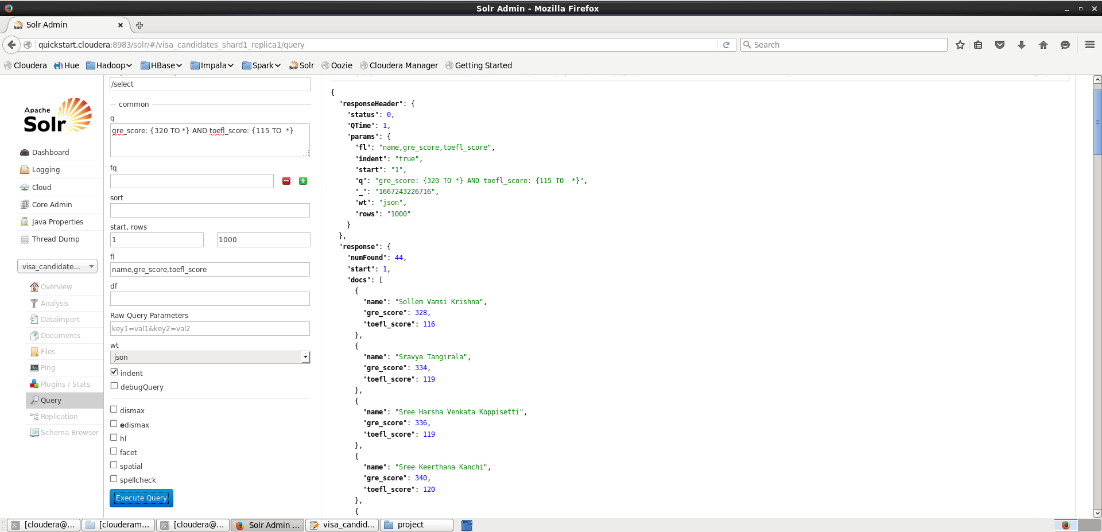

Here we are displaying the score and names of people who secured marks above 320 in ‘GRE’ and above 115 in ‘TOEFL’. To display this we used gre_scores and toefl_scores and combined both relations with the ‘AND’ Operator.

Finding University Rating

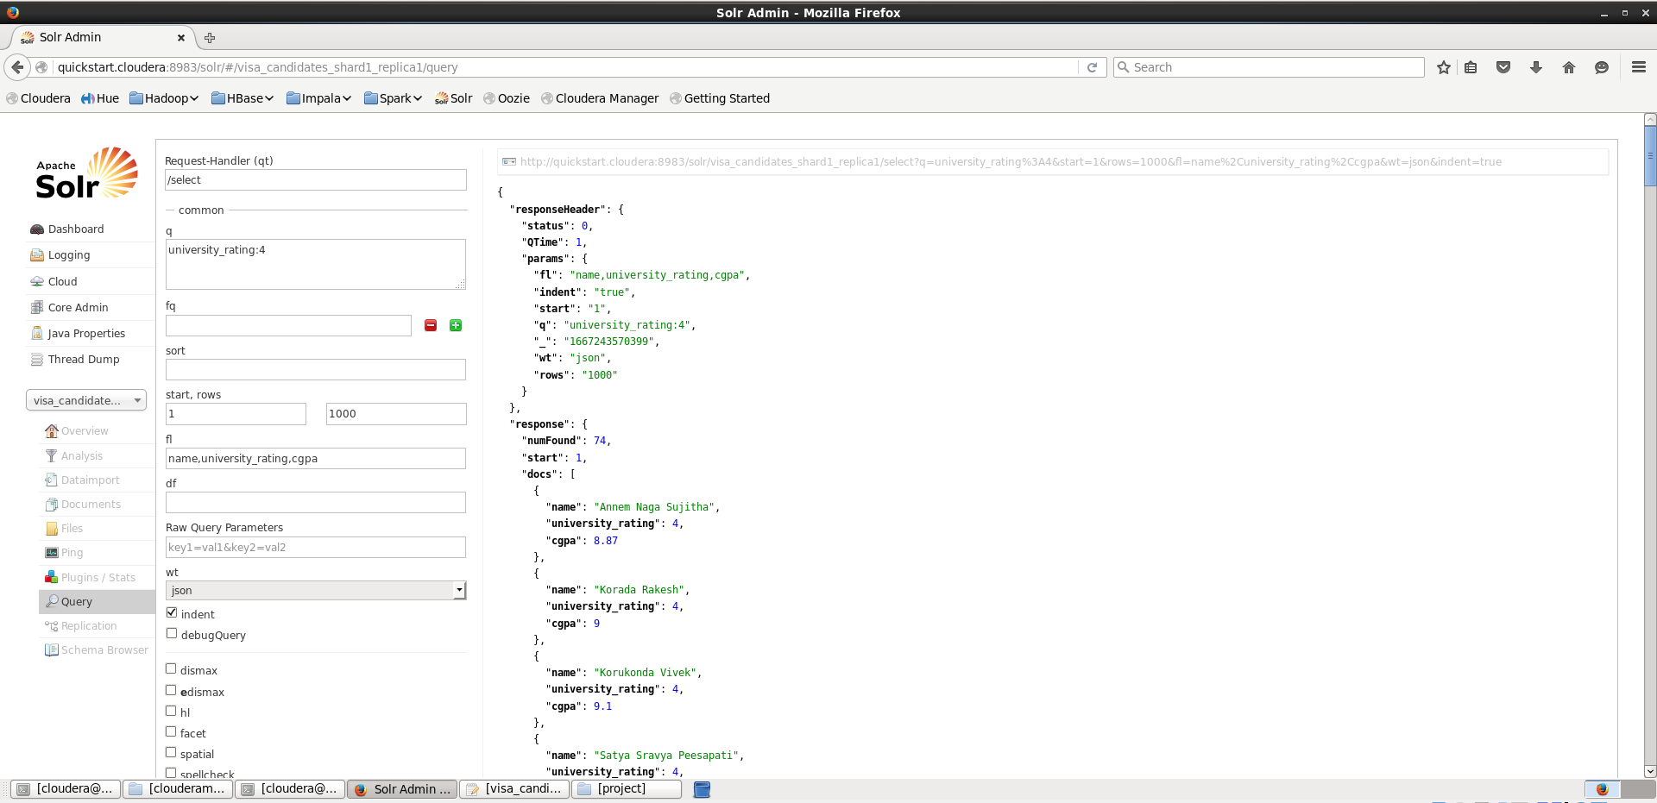

To display the university rating we should use the “university_rating:4” query so the universities whose rating is 4 will be retrieved above image is the output.

Total Criminal Records

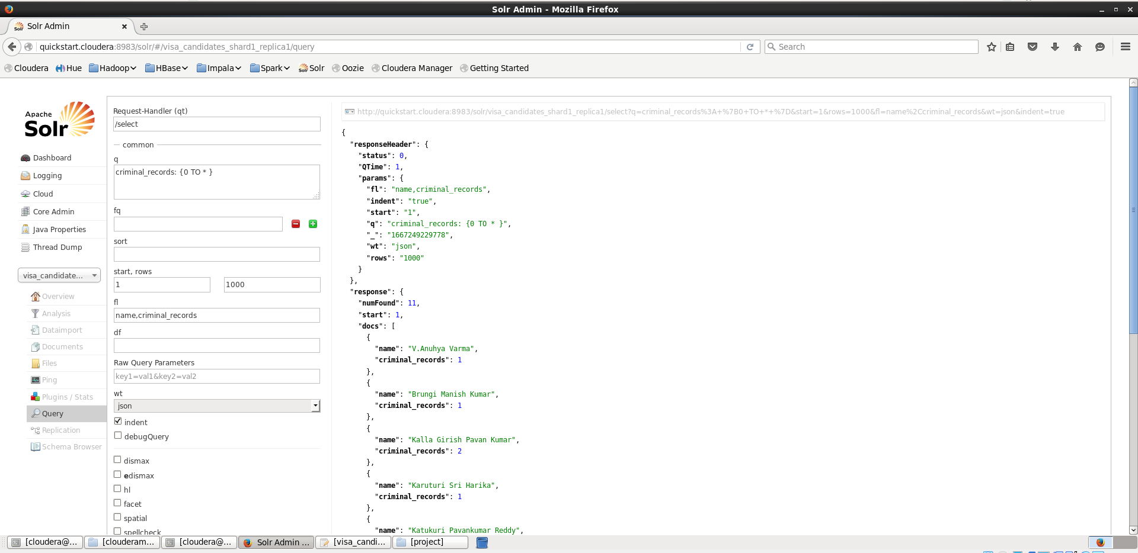

To display people who have criminal records we must use the “criminal_records:{0 to *}” query , in which the values inside flower brackets are from min number to maximum number , here ‘*’ means topmost number in the dataset and this will provide the output with the people name and their criminal records count .

Final Query

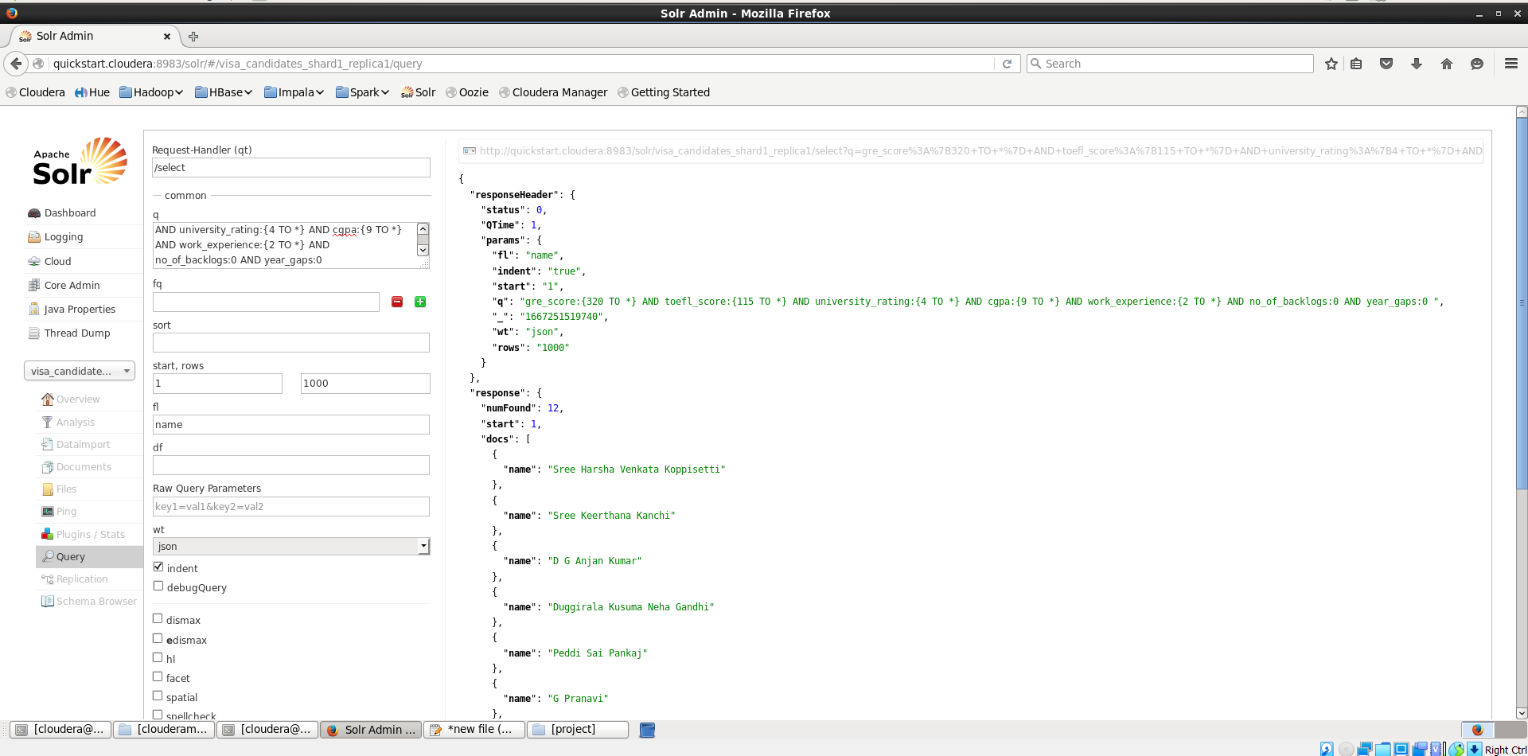

Here we are finding the names of people with best possible profile based on the uploaded data by the above command, from which we are sorting out the people whohaves university ratingof 4 and above ,CGPA of 9 and above, work_experience of 2 plus years with zero backlogs and no year_gap.

**Cassandra**

Opening of Cassandra

We created a keyspace with the name group17 and the replication is done shown as above

Creating of table

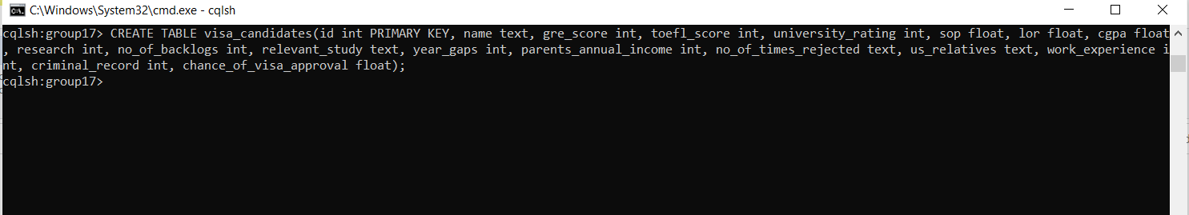

Now we created a table with name visa_candidates and described its attributes are shown as above.

Inserting values into the table

Now after creating the table we have loaded the data into the table using the local CSV file which is present in our system, using the appropriate command.

Checking whether the data is loaded or not

Using select * we can see all the data in the table so that we can check whether all data is imported or not into the

table.

Finding the highest approval chances based on some conditions

For this, we have taken some considerations such as gre_score, toefl_score, chance_of_visa_approval, cgpa

and their parents_annual_income.

Null value insertion

Here by checking the value at id =75 we found that the cgpa value is null.

* Using the update and set command we have inserted the cgpa value for the id=75.
* Also, check whether the value is reflected or not by using the select command

**Data Pre-Processing:**

Here we are trying to use libraries like pandas, NumPy, and matplot lib by importing them first. Then we

create a data frame by using the read_csv(file path) method. Next, we check the data frame by viewing the head and tail of the data frame.

Dataframe.info() gives details of the dataset like the columns and number of entries and their datatypes as shown above.

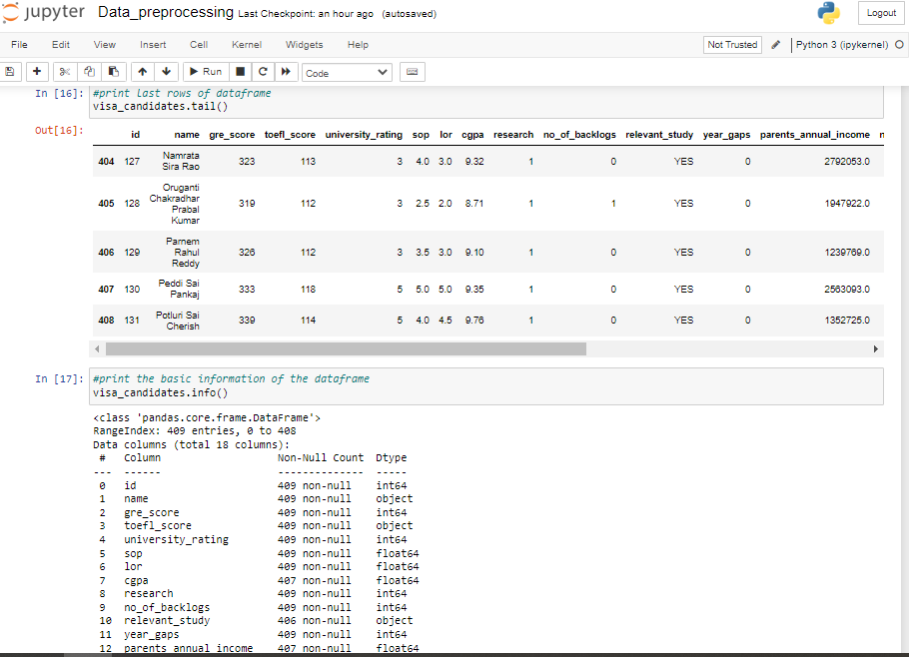

Dataframe. describe() provides the basic statistics of the dataset like count, range, maximum, minimum, average/mean, median, and standard deviation as shown.

Next, we check if there are null values in our data using. ISNA().sum().

Here we try to drop these null values using drop() and check for null values again using ISNA().sum().

Next, we check for duplicate rows and then remove these duplicates using drop_duplicates() and check again for any duplicates.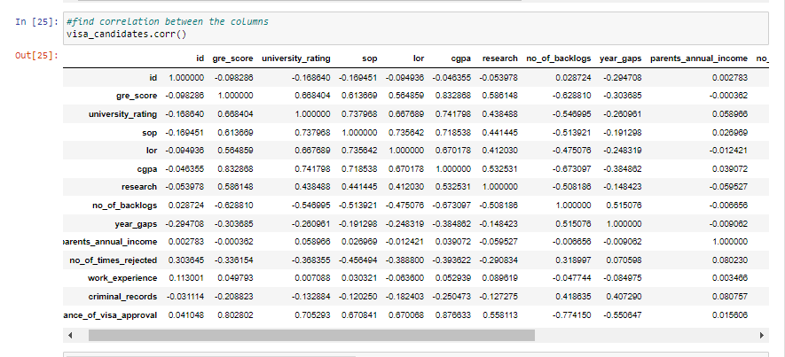

Here we try to find out the correlation between the columns in the dataset, more specifically we are trying to get the relation between each column and visa_chances prediction.

The next few figures are visual representations of these relations between a few important columns and visa_approval_chances like gre_score, cgpa,no_of_backlogs, etc using a plot. scatter(x,y).Chart, scatter chart

* The students test scores and chance of visa approval are directly proportional to each other. If the students have good test scores then the probability of getting visa is increased greatly.

*

* The higher CGPA will greatly improve the chance of visa approval.

* Similar to that of test scores and cgpa. The relation between university_rating and chance of visa approval is directly proportional.

* The no of backlogs is inversely proportional to the chance of visa approval. If the no of backlogs are high then the visa approval chances are greatly reduced.

As a final step in data preprocessing, we convert any string-indicated values to integers like yes/no values here and are mapped to 1/0 values for further processing.

**Analysis and Preliminary Results:**

* The above plot graph depicts the correlation between CGPA and the Chance of visa approval
* The parent’s annual income contributes only a partton the criteria but high annual income can bolster the students profile and can help in improving approval chances
* The chance of visa approval and criminal records are inversely proportional to each other. Any prior criminal records in the student’s profile will tremendously affect the visa approval rate.

**Machine learning:**

* To implement the machine learning part, First, we split the data into two different sets in one set we used 75% of the data for training the machine learning models and the remaining 25% for testing purposes. In the second set, we used 80% for training purposes and the remaining 20% for testing purposes.
* For each dataset we have used five machine-learning algorithms namely Multiple linear regression, KNN regression, Decision tree regression, Random Forest regression, and SVM regression. We fit models using these algorithms and the data we processed earlier and find the accuracy of the predicted output.

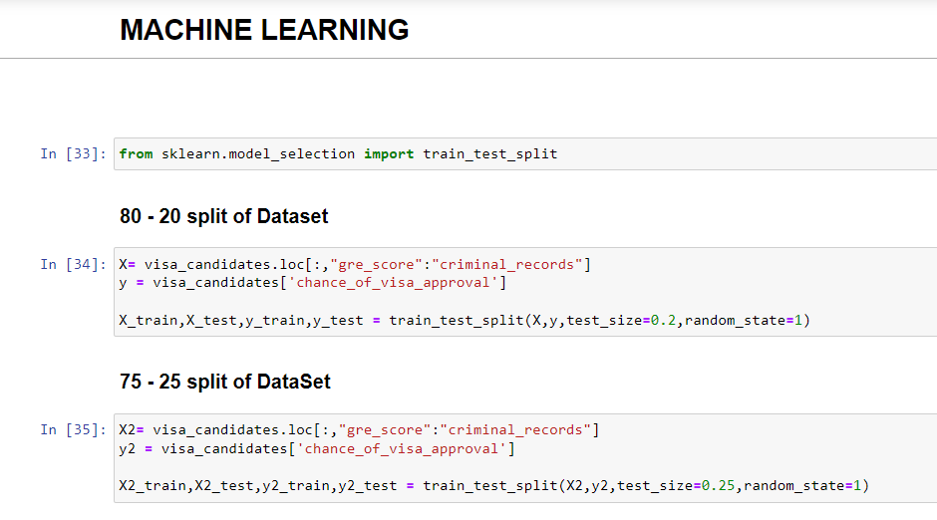

* The above screenshot represents the splitting of pre-processed data into two different sets. One set uses 80% of data for training and 20% for testing. Another dataset uses 75% for training and 25% for testing purposes.

**Multiple Linear Regression:**

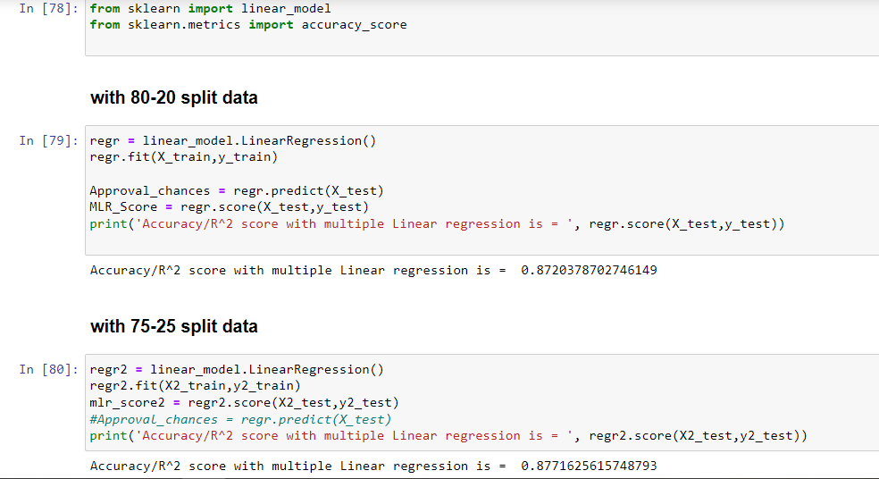

* We have used multiple linear algorithms for regression to fit in our models and executed the model on both datasets and the accuracy on these datasets is depicted in the above screenshot.
* Multiple linear regression is a statical technique commonly known as multiple regression. It is a statistical method for predicting the result of a response variable by using two or more explanatory factors. Unlike the linear regression which uses the single explanatory variable, Multiple linear regression which is extension to linear regression uses two or more explanatory variables.
* Formula to calculate multiple linear regression

***yi*​=*β*0​+*β*1​*xi*1​+*β*2​*xi*2​+...+*βp*​*xip*​+*ϵ***

*yi* ​=dependent variable

*xi* ​=explanatory variables

*β*0​ = y-intercept

*βp* = slope coefficients

*ϵ*=the model’s error term

**K- Nearest Neighbor:**

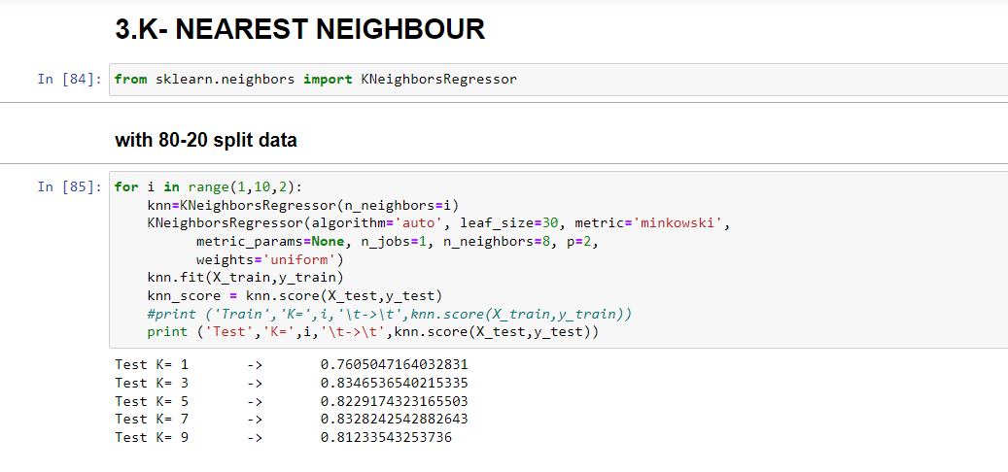

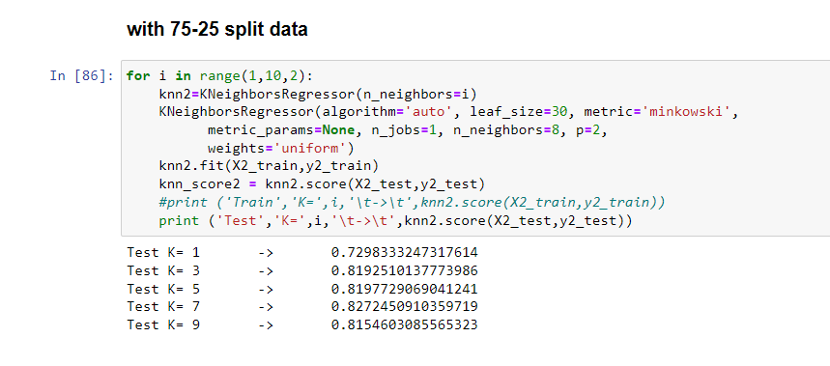

* Now we have used the K- nearest neighbor algorithm on both datasets and the accuracy of the predicted output for different K values is depicted in the above screenshot.
* KNN is a machine learning algorithm which can be used for both regression and classification. By calculating the distance between all training points and test data the KNN predicts suitable class for the test data. The KNN algorithm determines the possibility that each of the "K" training data classes will contain the test data, and then it selects the class with the highest likelihood. In a regression scenario, the value is the mean of the 'K' selected training points. KNN is a non-parametric technique. Which estimates the relation between independent variables by considering the mean of the data that belongs similar neighborhood and the continuous result.

**Decision Tree Regression:**

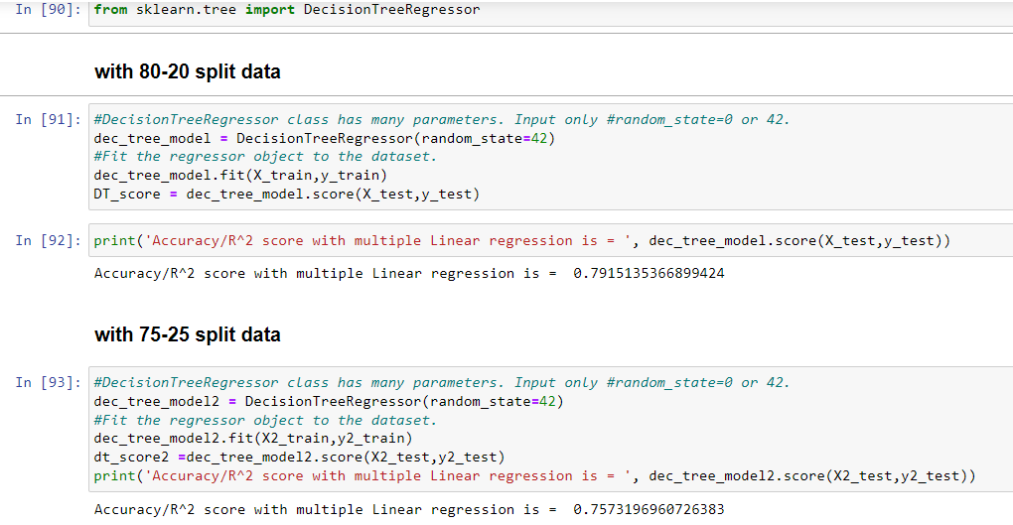

* Here we have used the Decision tree algorithm to find the accuracy of the predicted output. We have executed the Decision tree algorithm on 2 datasets and the outcomes of this algorithm are shown in the above picture.
* In order to forecast data in the future and provide useful continuous output, decision tree regression trains a model using the characteristics of an object's features. Continuous output denotes that the output or result isn't discrete, i.e., it's not exactly a discrete, well-known collection of values and numbers.

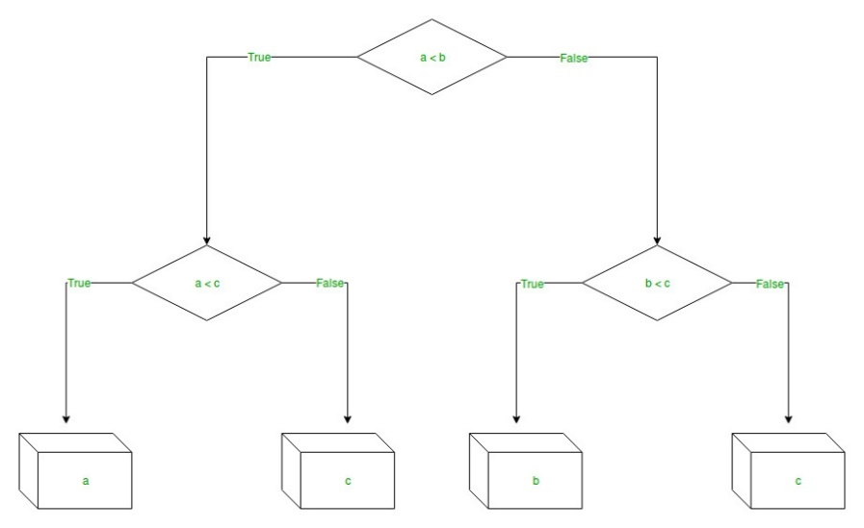Fig 3: Decision Tree

**Random Forest Regression:**

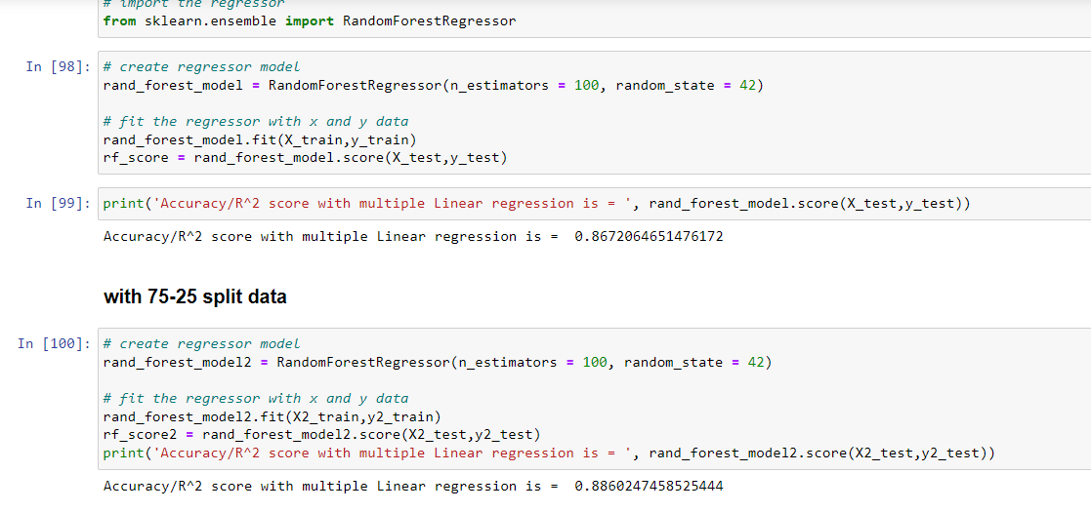

* Here we have created a regression model using the random forest algorithm and fitted the model with a random forest regressor to evaluate the accuracy of the predicted output. The accuracy values are shown in the above screenshot.
* A supervised learning technique called Random Forest Regression leverages the ensemble learning approach for regression. The ensemble learning approach combines predictions from many machine learning algorithms to provide more accurate predictions than those from a single model.

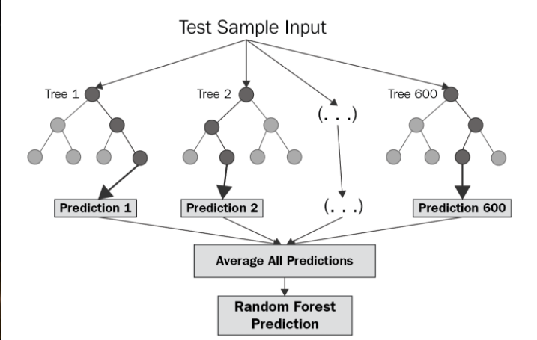

Fig 4: Random Forest

**SVM Regression:**

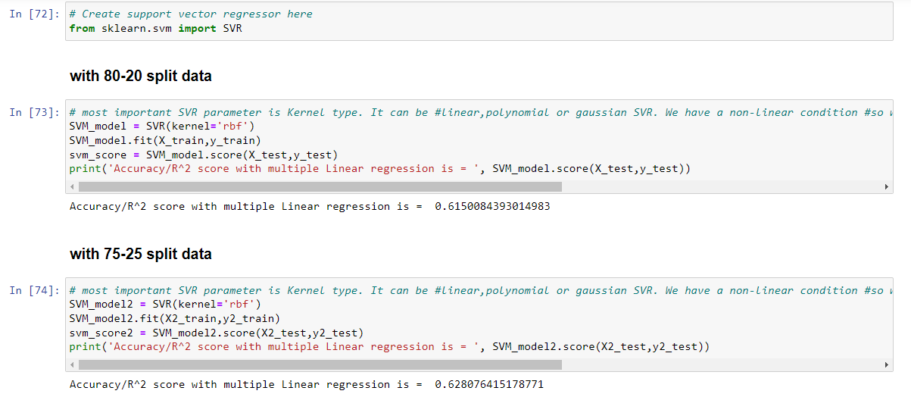

* Here we have created a regressor using the Support Vector Machine algorithm and fitted the model with this regressor. We have executed this model on both datasets and the accuracy of the model is displayed in the above snippet.
* The Support vector regression is a common ML algorithm widely used in regression and classification problems. Since SVM regression is highly dependent on kernels for processing, this algorithm is considered as a non-parametric algorithm. SVM algorithm works by mapping the data in datasets to a high-dimensional feature space so that data points can be easily categorized even when the data is not linearly separatable.

**Results:**

**Multiple Linear Regression:**

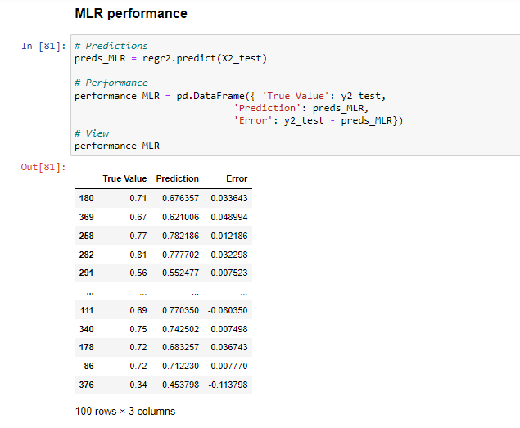

* In the above screenshot, we are calculating the performance of Multiple linear regression and displaying the true value that is stored in y2_test, Displaying the predicted values that we calculated using the model and the error that is obtained by subtracting the predicted from the true value
* . In the error column, we could observe some are positive errors and some are negative errors. If the predicted value is greater than the actual value, then the resulting error is a negative error.
* If the predicted value is less than the actual value, then the resulting error is a positive error

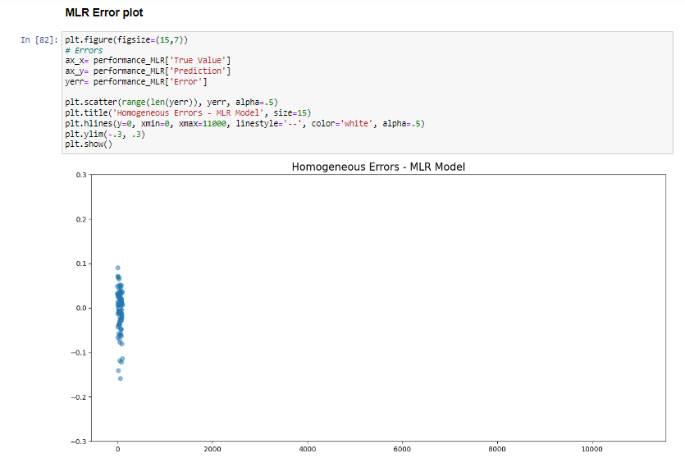

* The above snippet represents a scatter plot graph plotted by error value we obtained by subtracting the predicted value from the actual value.
* Most of the values are close to zero.

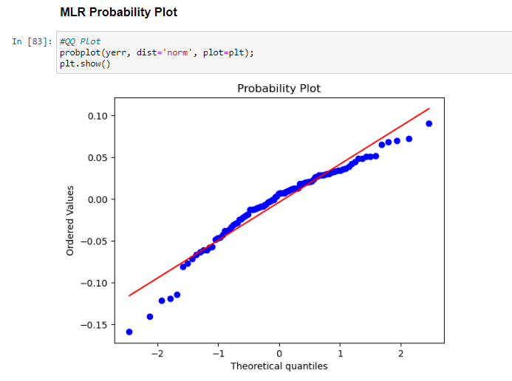

* This probability graph displayed in the above snippet shows how close are the predicted values to the actual values. The red solid line represents the actual values, while blue dots represent the predicted values, and we could see using the MLR algorithm the predicted values are close to the actual values.
* The theoretical values are on the x axis and the ordered values are on y axis.

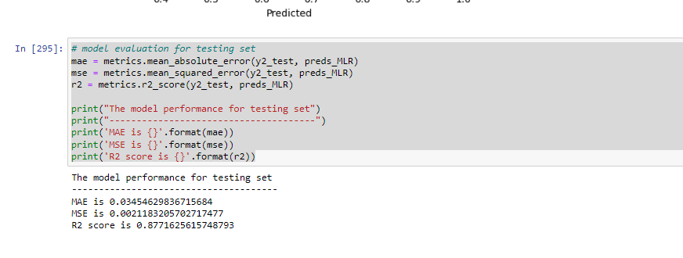

* Here we are evaluating the model based on mean absolute error (MAE) and mean squared error (MSE) and also based on the R2 score.
* We have used metrics package for finding the values of MAE, MSE and R2.
* Based upon the R2 score we will evaluate the model percentage.

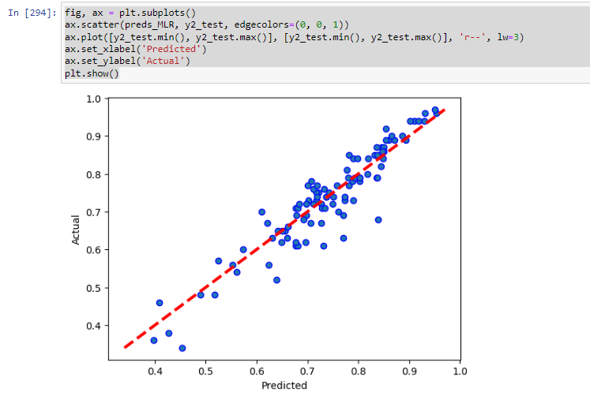

* Here we created a graph that is plotted based on predicted and actual values.
* On the x axis predicted values are there and on y axis actual values are present.
* Moreover the graph values are in a straight line.

**KNN Regression:**

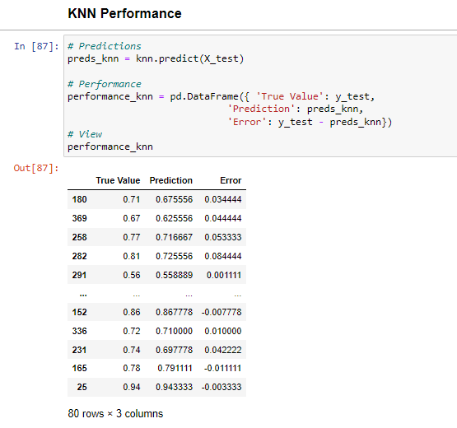

* In KNN regression, the model stores all the values and it then predicts the target based upon similarity measure.
* In the  image, we are calculating the performance of KNN and the true value is stored in y_test, the predicted values derived using the model which we got by the knn.predict from x_test, and the error achieved by subtracting the predicted from the true value.
* The errors can be positive or negative errors.

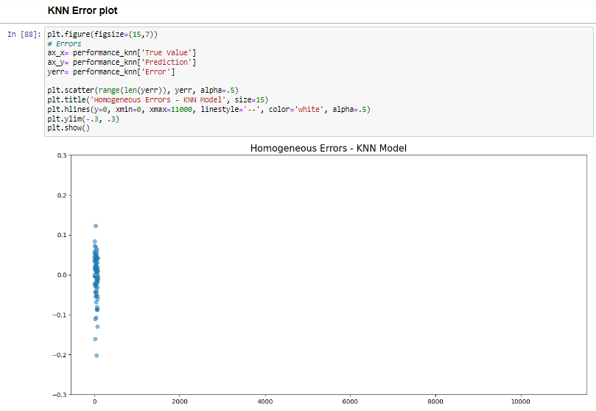

* In the snippet above, a scatter plot graph with error values that were derived by subtracting the expected value from the actual value is displayed.
* As we observe the graph, we can see that the graph is similar to the above model graph and the values are close to the zero.

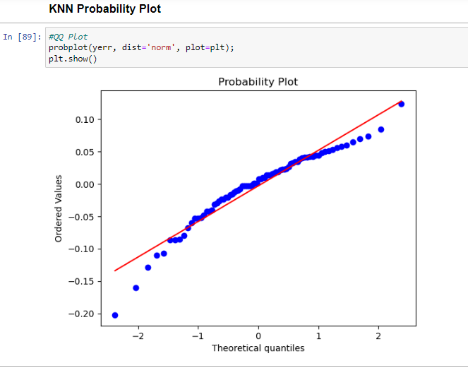

* This probability graph displayed in the above snippet shows how close are the predicted values to the actual values.
* The red solid line represents the actual values, while blue dots represent the predicted values, and we could see using the KNN algorithm the predicted values are close to the actual values.
* Suppose take the theoretical value of -0.19 so it matches to the ordered value of -0.14.

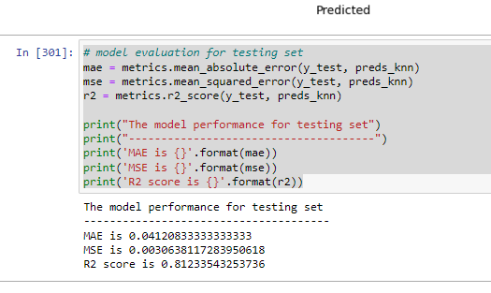

* Here, we assess the model using its mean absolute error (MAE), mean squared error (MSE), and R2 score.
* The main thing that we consider is the R2 score that is accuracy which helps to find out which is the best model.
* The mean absolute value for the above model is 0.041208 and the mean square error is .003063 and the R2 value is 0.812335.

**Graph of predicted values to actual values**

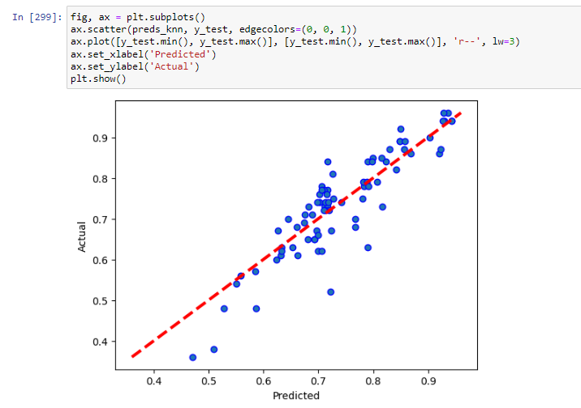

* Here we created a graph that is plotted based on predicted and actual values.
* As we can see most of the predicted values are close to the actual values.
* Take the values from 0.6 to 0.7 we can see all the values are close to each other.

**Decision Tree Regression:**

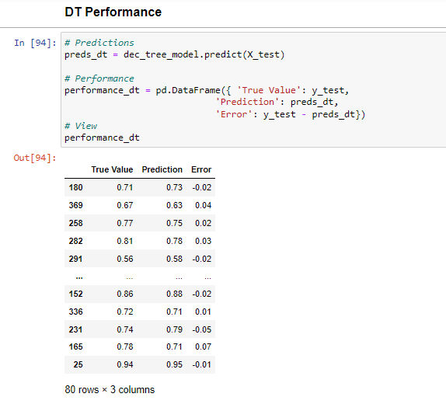

* Here, we are calculating the performance of Decision Tree regression and displaying the true value that is stored in y2_test, Displaying the predicted values that we calculated using the model and the error that is obtained by subtracting the predicted from the true value.
* In the error column, we could observe some are positive errors and some are negative errors. If the predicted value is greater than the actual value then the resulting error is a negative error, else it is a positive error.
* The error values and near to zero in most of the cases.

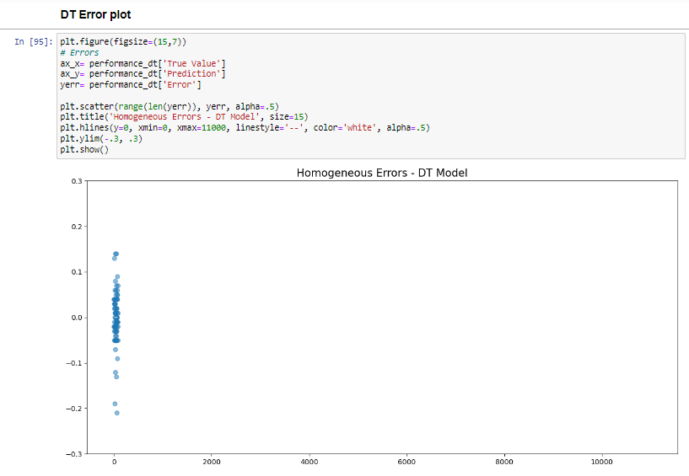

* In the above image, we have plotted a graph with error values that were obtained by subtracting the expected value from the actual value is displayed.
* This is almost same as the above graph the values are close to zero.

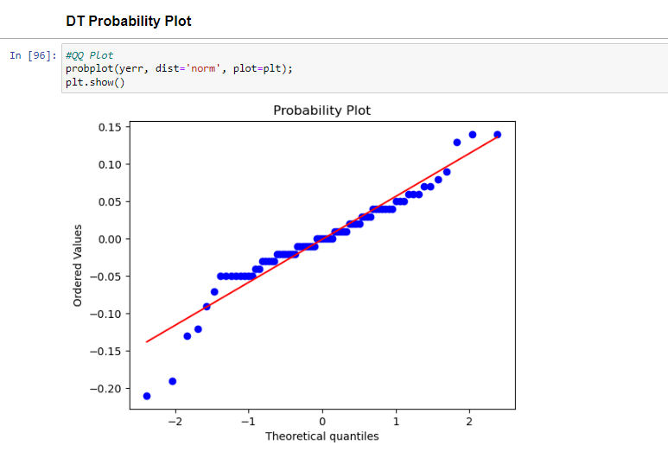

* Here we are plotting the graph between the Theoretical quantities and the ordered values and the resultant graph is probability graph, here red line is the actual value and all the blue dots are the predicted values we obtained by Decision tree algorithm.
* The probability plot of decision tree is different when compared to the above two graphs.

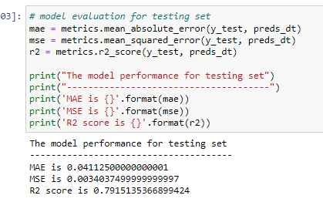

* Here, we evaluate the model using its R2 score, mean squared error (MSE), and mean absolute error (MAE).
* These are the main features which will show hoe good a model is.
* The MAE value is 0.04112, MSE value is 0.003403 an the R2 value is 0.79151.
* The accuracy value is low compared to above models.

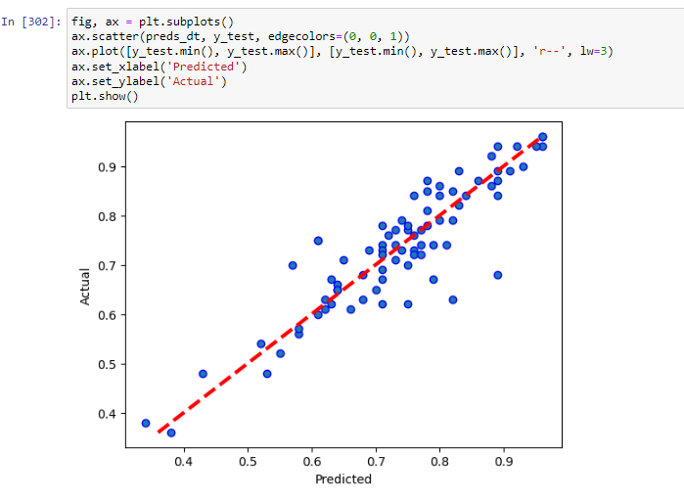

* Here, a graph based on expected and actual values has been constructed.
* For instance, take the 0.6 value of predicted which matches to the 0.6 value of the actual value.
* And the last value of predicted is 1 is which is same to 1 in predicted.

**Random Forest Regression:**

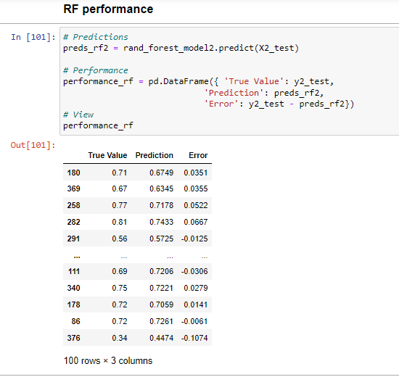

* In this section, we calculate the effectiveness of Random Forest Regression and display the real value that is stored in y2_test, the predicted values that we computed using the model, and the error that is derived by deducting the predicted from the true value.
* We can see that some of the errors in the error column are positive and some are negative. The resulting error is either positive or negative depending on whether the anticipated value is bigger than the actual value.

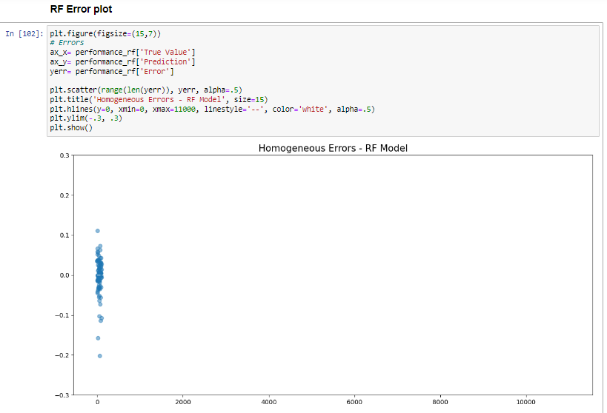

* The graph showing error values that were obtained by deducting the expected value from the actual value is shown in the above image.
* We can see the above result is similar to all the above graphs.

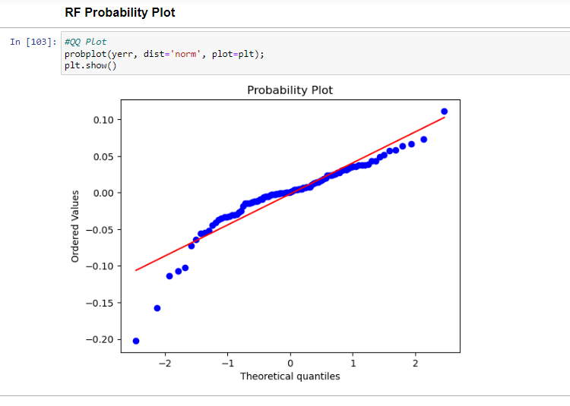

* The red line represents the actual value, and all the blue dots represent the predicted values we received using the Random Forest algorithm. In this graph, we are charting the relationship between theoretical quantities and ordered values, and the resultant graph is a probability graph.

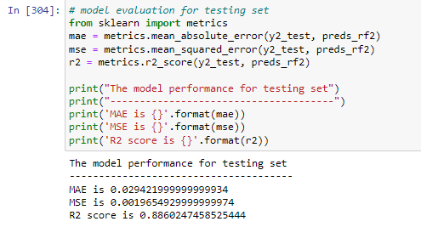

* Here, we are doing the model evaluation by mean absolute error and mean square error and also base on the r2 score above image displays the values of these respectively.
* The R2 value is 0.8860 and MAE is 0.294 and the MSE is 0.0019.

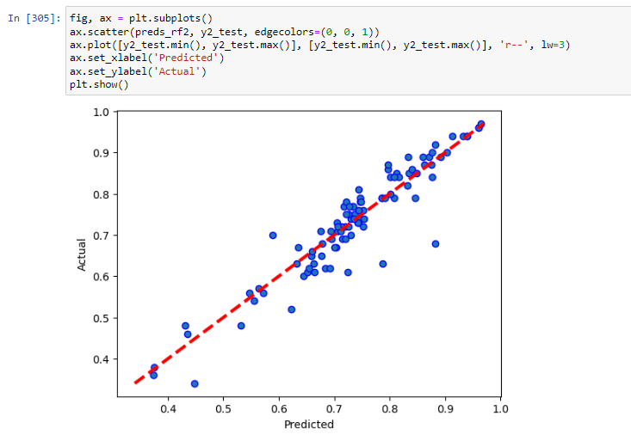

* Here, an expected and actual value graph has been created for Random Forest regression model.
* Most of the values are common in predicted and actual value between the 0.7 to 0.8 values.

**SVM Regression:**

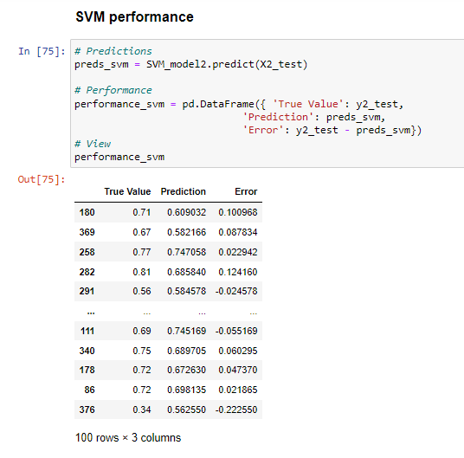

* The efficacy of SVM Regression is determined in this part, and the true value that is stored in y2_test, the predicted values that we computed using the model, and the error that is produced by subtracting the predicted from the true value are all displayed.
* We can see that there are both positive and negative mistakes in the error column. Depending on whether the anticipated value is greater than the actual value, the resulting error can be either positive or negative.

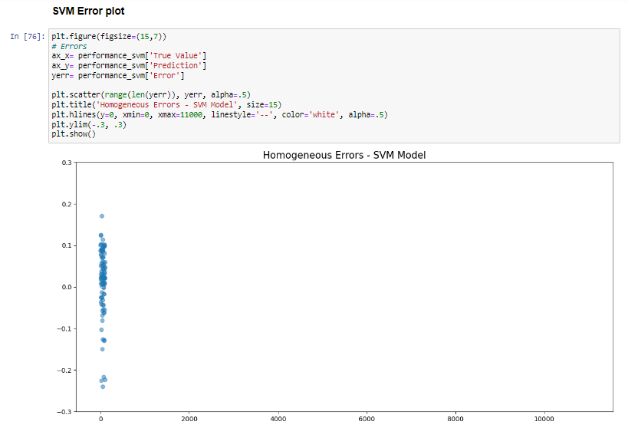

* The figure above displays a graph of the error values that were calculated by subtracting the expected value from the actual value.
* The values are close to zero in many of the cases.
* And this graph is similar in all the regressions.

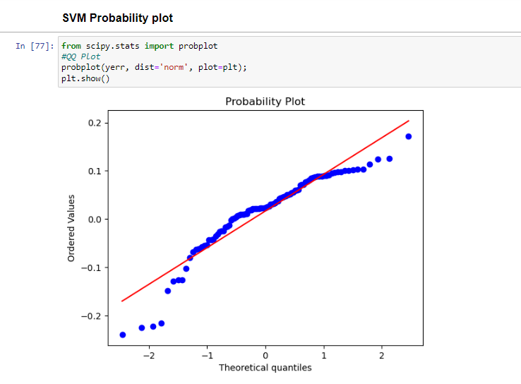

* The blue dots reflect the anticipated values we received from the SVM method, and the red line represents the actual value.
* This graph is a probability graph because it shows the relationship between theoretical quantities and ordered values**.**

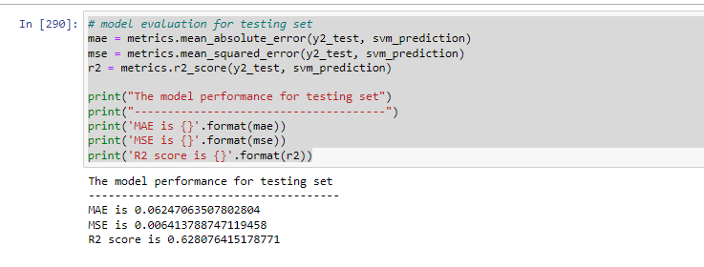

* In this case, we are evaluating the model based on its mean absolute error = 0.06 and mean square error=0.006, as well as the r2 score = 0.62, which is displayed in the above image.
* The R2 value is more important compared to all the values.

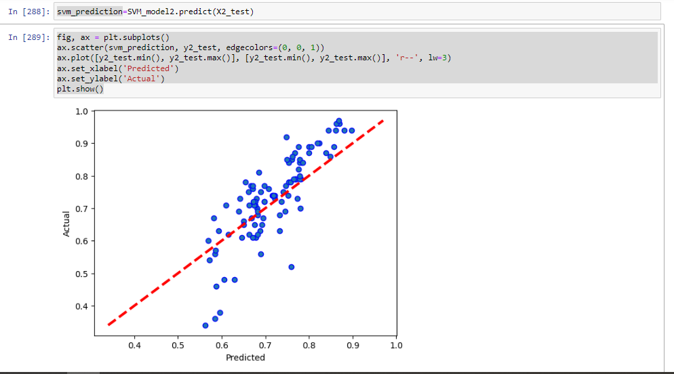

* Above graph depicts the linear relation between expected and actual value graph as shown here for SVM model.
* Most of the values in predicted and the actual are common around 0.7 value.

**Final Comparison and Prediction check:**

As shown above , after comparing the R2 score or accuracy obtained from all 5 algorithm models with both 80-20 split data and 75-25 split data , It is evident that Random forest regression and multiple linear regression model performed way better than other 3 models. Hence We choose random forest model with 75-25 split data as it has the highest accuracy of 88.6 score.

With the chosen model , we try to check the prediction for any particular row. For example , we tried to input the feature values of Mr. mathsa Vikash who got 0.90 i.e., 90% chances of visa approval as original prediction. When checked with Random Forest model , we got 0.8986 as prediction which is almost equal to 90%.

**Project Management:**

**Work Completed:**

* ***Description***

We aimed at finishing the data analysis part of the project which we finished . We used HDFS to store our dataset in Hadoop by making a directory and putting our dataset into it. Then we used hive for easy query execution instead of implementing direct map-reduce code. We created hive tables and ran different queries analyzing the data. Then we implemented the same queries in Solr-Lucene and Cassandra too.

|  |  |
| --- | --- |
| Suhas Siddarajgari Tellatakula | Data analysis features, Data Preprocessing, Machine Learning features, Data visualization and making report. |
| Sai Tejesh Gonemadatala | Data analysis features, Data Preprocessing, Machine Learning features, Data visualization and making report. |
| Sai Rohith Varma Kantem | Data analysis features, Data Preprocessing, Machine Learning features, Data visualization and making report. |
| Sai Praneeth Reddy Avula | Data analysis features, Data Preprocessing, Machine Learning features, Data visualization and making report. |

Next , we split the data into training and testing sets and implemented 5 Machine Learning regression algorithms namely Multiple Linear regression, K Nearest Neighbor , Support Vector Machine , Decision Tree regression , Random Forest Regression. Then we analyzed the performance of these 5 models and picked the best possible model which in our case is Random Forest regression model when data is split into 75% training data and 25% testing data.

* ***Responsibility***
* ***Contributions***

|  |  |
| --- | --- |
| Suhas Siddarajgari Tellatakula | 25% in implementing Data analysis features, Data Preprocessing, Machine Learning features, Data visualization and making report. |
| Sai Tejesh Gonemadatala | 25% in implementing Data analysis features, Data Preprocessing, Machine Learning features, Data visualization and making report. |
| Sai Rohith Varma Kantem | 25% in implementing Data analysis features, Data Preprocessing, Machine Learning features, Data visualization and making report. |
| Sai Praneeth Reddy Avula | 25% in implementing Data analysis features, Data Preprocessing, Machine Learning features, Data visualization and making report. |

* ***Issues***
* Finding the appropriate dataset for our problem statement was difficult.
* Cleaning the dataset and renaming the column names meaningfully.
* Implementing the data analysis on Hadoop ecosystem on a single laptop was difficult as a group.
* Implementing 5 models for both 80-20 and 75-25 split datasets every time and picking the right datasets every time was a confusing task as we are used to fit for only one dataset.
* Sometimes , the data saved in csv format used to give NaN values unknowingly. We used to pick up the dataset from backup most of the times.

**References / Bibliography:**

1. <https://www.kaggle.com/code/aryantiwari123/graduate-admission-prediction>
2. <https://www.kaggle.com/datasets/saddamazyazy/go-to-college-dataset>
3. <https://www.jetir.org/papers/JETIR2204278.pdf>
4. <https://www.kaggle.com/code/akhilkasare/h-1b-visa-prediction-using-machine-learning>
5. <https://www.kaggle.com/code/campusx/gre-admission-prediction/data>
6. <https://ieeexplore.ieee.org/document/8933628>
7. <https://www.wallstreetmojo.com/multiple-regression-formula/>
8. <https://towardsdatascience.com/machine-learning-basics-multiple-linear-regression-9c70f796e5e3>
9. <https://bookdown.org/f100441618/bookdown-regresion/ml-tools.html>
10. <https://www.geeksforgeeks.org/python-decision-tree-regression-using-sklearn/>
11. <https://levelup.gitconnected.com/random-forest-regression-209c0f354c84>
12. <https://medium.com/it-paragon/support-vector-machine-regression-cf65348b6345>